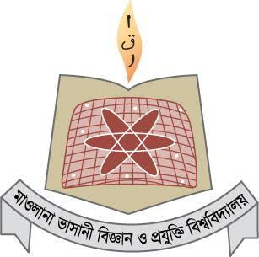

MAWLANA BHASHANI SCIENCE AND TECHNOLOGY UNIVERSITY

Santosh,Tangail-1902

**LAB REPORT**

Lab Report No : 02

Lab Report name : Basic command of linux operating system.

Course Title :Operating System Lab

Course Code :ICT-3110

Date of Performance :

Date of Submission :28/9/2020

Submitted by,

Name : Farhana Afrin Shikha

ID :IT-18038

Session : 2017-18

3rd Year 1stsemester

Dept. of ICT

Submitted to,

Nazrul Islam

Assistant Professor

Dept. of ICT,

MBSTU.

Lab Report No-02:Basic Command of Linux Operating system

**i)What is Linux command?**

Ans:Linux is a Unix-Like operating system.all the Linux commands are run in the terminal provided by the Linux system.The terminal is just like command prompt of Windows OS.Linux commands are case sensitive.The terminal can be used to accomplish all Administrative tasks.This includes package installation,file manipulation and user management.The Linux terminal is user interactive.Execution of typed command is done only after you press the Enter key.

**ii)Write 15 command in Linux operating system.**

**1.pwd**

**2. ls**

**3. cd**

**4. mkdir & rmdir**

**5. rm**

**6. touch**

**7. man & --help**

**8. cp**

**9. mv**

**10. locate**

**11. echo**

**12. cat**

**13. nano**

**14. sudo**

**15. df**

**iii) Describe the operation of Linux basic command**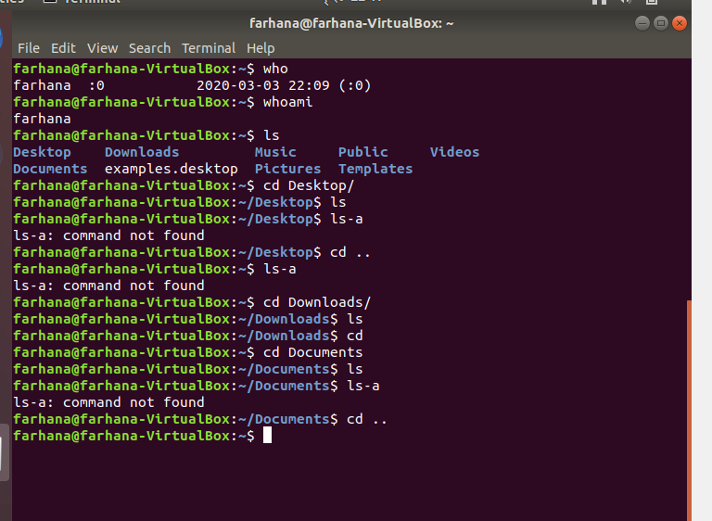

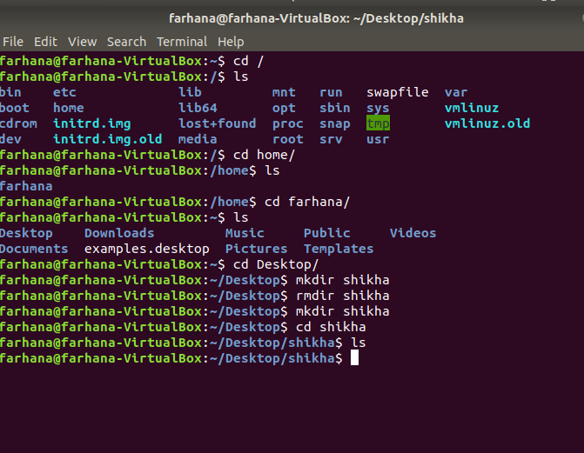

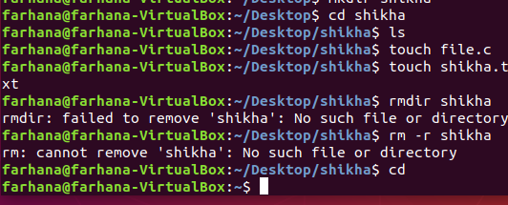

Conclusion:Linux is an operating system.It is free and open source that means anybody can simply change anything in linux.There are several linux distributions.In this lab report I have written about some linux basic command.Such as :pwd, ls,cd, mkdir & rmdir,rm ,touch , man & --help ,cp , mv ,locate , echo etc.This basic commands are mostly used in linux operating system.’PWD’ means present work directory.It indicates the current directory.When I first open the terminal I am in the home directory.To know which directory I am in , I can use the pwd command.Then ‘ls’ means list of a directory, I can see all the hidden files by using the command ls-a,I can use the ‘cd’ command to go to a directory. mkdir and rmdir indicates make diretry and remove directory respectively and so on.The touch command is used to create a file and cp command is used to copy a file.These are some important linux command.By using this command we can do many things.In the above I have given some working example of linux basic command in terminal of linux.For doing this I don’t have face any problem.